1 Find the downloaded file and make the sure the name is apollo-contacts-export.csv

2 copy and paste the CSV into current folder;

3 Right click on the blank area and click on Open with Code;

4 Follow blow screenshot;

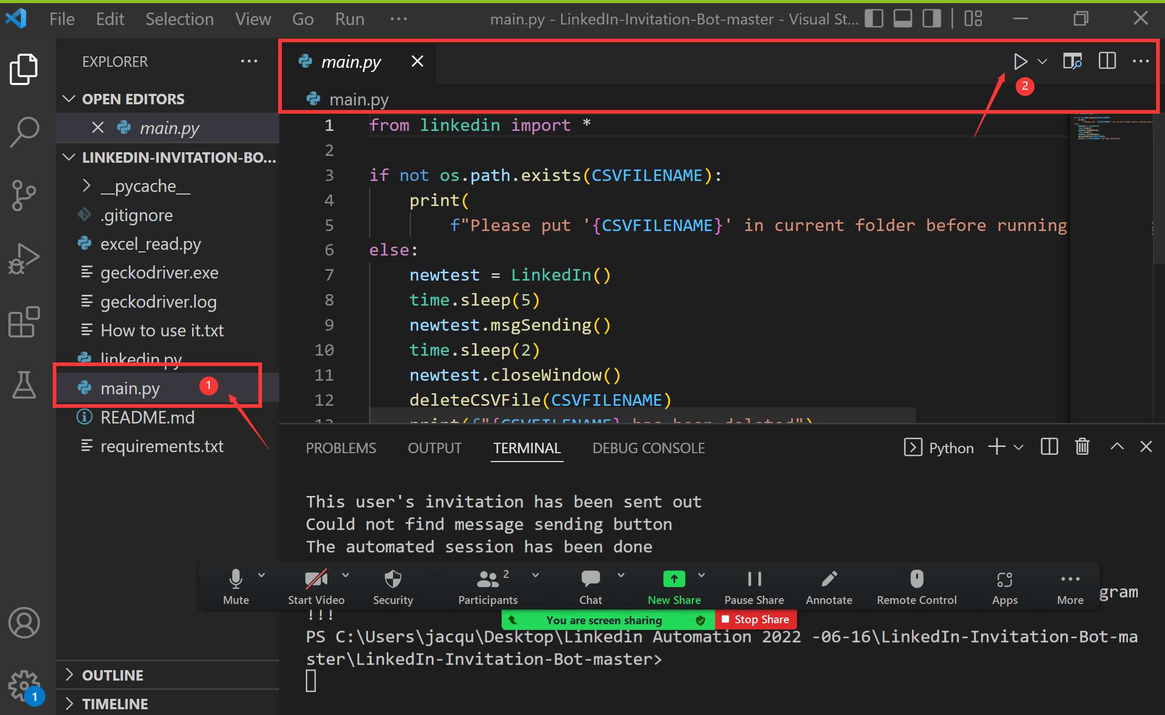

5. Once it is run, the CSV will be deleted.